Group 16 Design Document: Battery Temperature Monitor
Oct 22, 2026 · @Irei Hashimoto

1. Overview
This system monitors battery-cell temperatures, reports the hottest reading over I2C, and flags a fault above 60°C. Each temperature sensor produces a voltage that falls as temperature rises. A multiplexer connects one sensor at a time to a signal-conditioning stage, and the Arduino Nano's 10-bit ADC converts that voltage to a number. The firmware converts each reading to a temperature, finds the maximum across all channels, and sends it over I2C. A blinking red LED shows the system is running and indicates a fault. A 12 V to 5 V converter powers the board from the car's low-voltage battery.
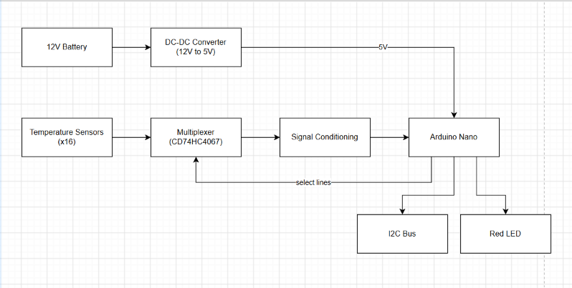
Figure 1: Block diagram

2. Requirements and assumptions
The project requires a circuit that reads 16 temperature sensors, converts them to digital values, and reports the highest temperature over I2C.
Requirements
- 16 temperature sensors
- A CD74HC4067 analog multiplexer (schematic); CD4051BE in the physical build
- A signal conditioning stage between the multiplexer and the Nano
- An Arduino Nano that converts each reading with its ADC and finds the highest temperature
- I2C output of that temperature
- A blinking red LED, with a fault indicated above 60°C
- A 12 V to 5 V DC-DC converter (schematic)
Assumptions
- Sensor supply: 5 V through 680 Ω, per the datasheet test circuit.
- The LV battery is nominally 12 V.
- The physical build reads 8 sensors through the CD4051BE, per the leads' update.
- ADC reference: default 5 V; the conversion formula uses 1024.

3. Hardware

3.1 Power
The 5 V rail comes from an LM7805MP regulator fed from the 12 V battery through diode D2, with input capacitors of 0.22 µF and 0.1 µF and output capacitors of 10 µF and 0.1 µF. In the physical build, a supplied 5 V source replaces it.
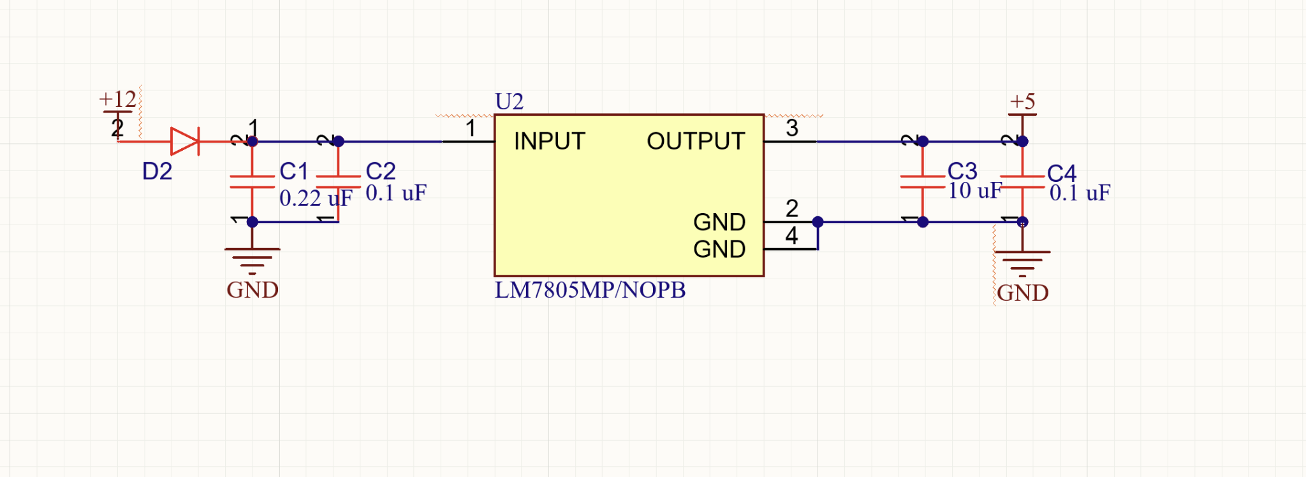
Table 1: 5 V rail current budget
Load | Current (mA) | Source
Sensors (worst case, 120°C) | 87.0 | 16 × (5.00 − 1.30) V ÷ 680 Ω = 16 × 5.44 mA; 43.5 mA for the 8-sensor build
Arduino Nano | 50
Mux | 0.008
LED | ≈ 10 | Set by the LED's series resistor
I2C pull-ups | 3.3 | 5 V ÷ 1.5 kΩ
Op-amp
Total | ≈ 150 + op-amp

3.2 Temperature sensors
- Each sensor is in series with a 680 Ω resistor between the 5 V rail and ground, which matches the test circuit in the sensor datasheet [1]. We match it because the datasheet's voltage-to-temperature table is only valid under those conditions.
- The resistor and sensor form a voltage divider, and the measured signal is the voltage at the point between them. As the sensor heats, its effective resistance falls, so its share of the 5 V falls. The sensor's voltage therefore drops as temperature rises.
Table 2: Sensor output at key temperatures (from datasheet Table 5 [1]); ADC readings include the conditioning gain of 2 (Section 3.4)
Temperature (°C) | Sensor voltage (V) | ADC input (V) | ADC reading (5 V ref)
−40 | 2.44 | 4.88 | 999
0 | 2.17 | 4.34 | 888
25 | 1.86 | 3.72 | 761
60 | 1.51 | 3.02 | 618
120 | 1.30 | 2.60 | 532

3.3 Multiplexer
- The MUX selects a channel from the binary code sent by the Arduino [4]. It follows this truth table:
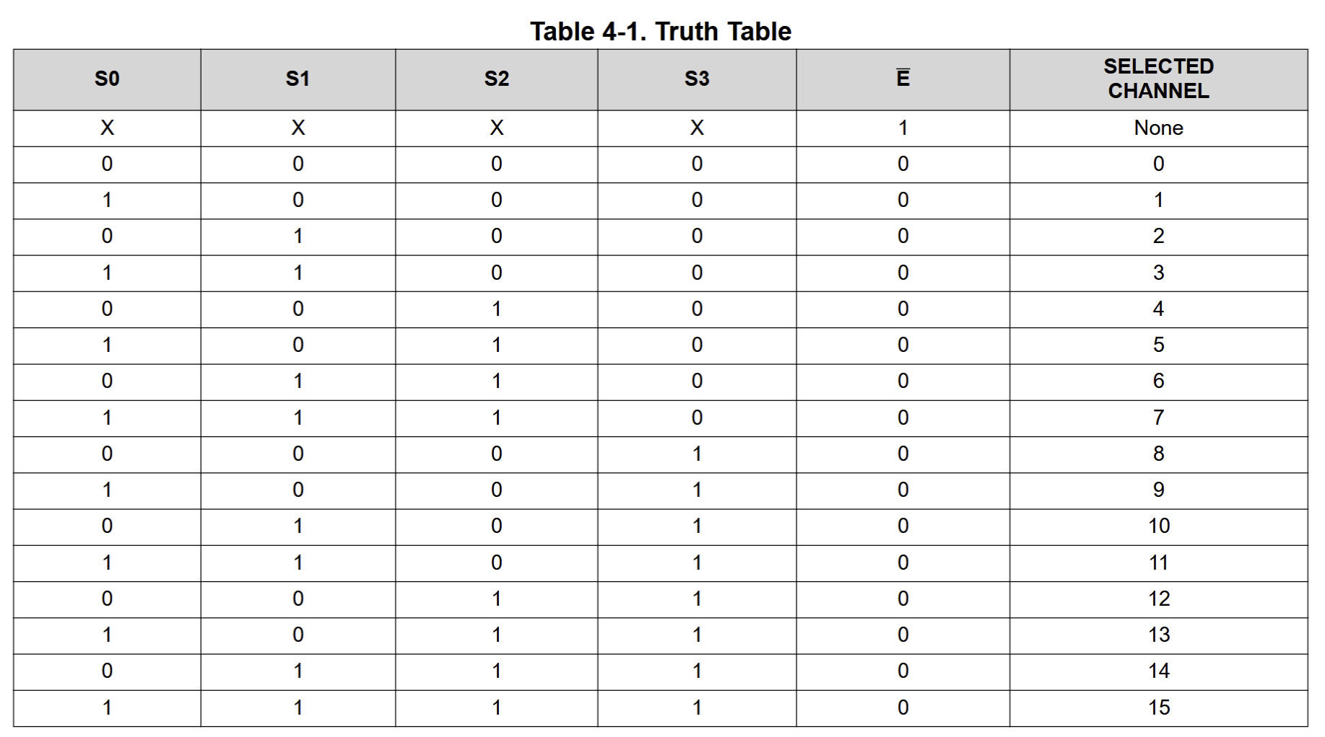
- The mux has an ON resistance of about 160 Ω at worst and 70 Ω typical [4].
- The settling time after switching channels is:
t_settle = N × (R_source + R_on) × C_total
= 6.93 × (670 Ω + 160 Ω) × 14 pF
≈ 80 ns
where N = 6.93 time constants (settling to 0.1%), R_source = 670 Ω, R_on = 160 Ω, and C_total = 14 pF (Nano ADC input).
- 80 ns is far shorter than the ADC's own sampling time (about 12 µs at the default settings [2]), so the signal has settled before each reading and no extra software delay is needed.

3.4 Signal conditioning
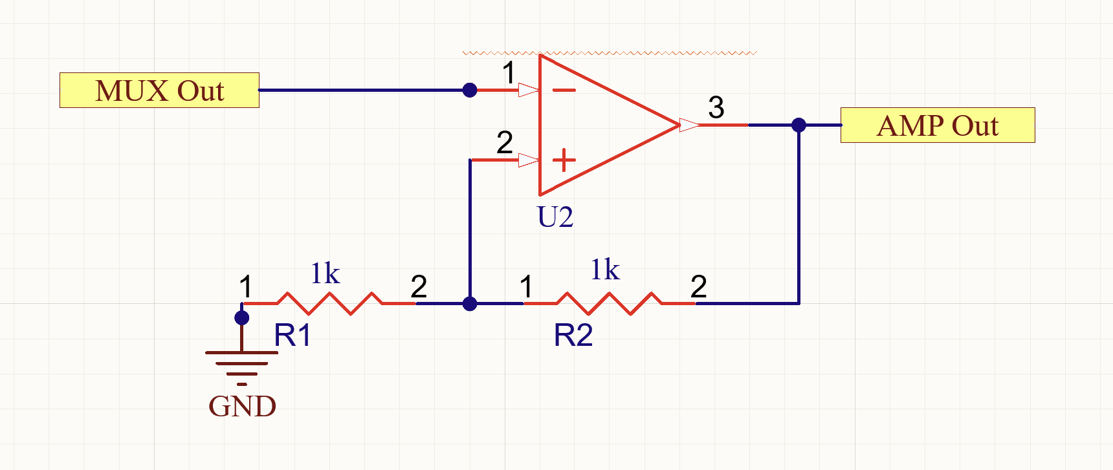
- The sensors produce a voltage of only 1.30–2.44 V, but the Arduino Nano's ADC spans 0–5 V. The signal uses less than a quarter of the ADC range, which lowers the resolution.
- To solve this, a non-inverting operational amplifier amplifies the signal with a gain of 2, set by R1 = R2 = 1 kΩ (gain = 1 + R2/R1 = 2). The ADC input becomes 2.60–4.88 V, which stays inside the 0–5 V range.

3.5 Nano and ADC
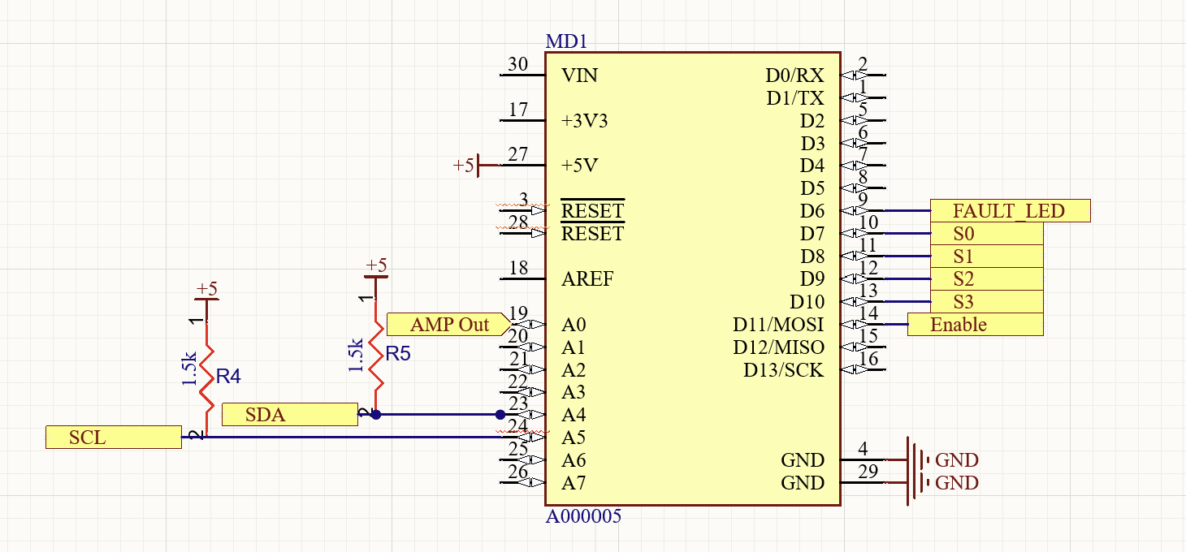
Table 3: Nano pin assignment
Pin | Function
A0 | Op-amp output (multiplexer signal)
D6 | Fault LED
D7, D8, D9, D10 | Mux select lines S0, S1, S2, S3
D11 | Mux enable (driven LOW to enable)
A4, A5 | I2C SDA, SCL
- ADC: 10-bit, 5 V reference, LSB = 5 V ÷ 1024 = 4.88 mV. The ADC input voltage is reading × 5 ÷ 1024; dividing by the gain of 2 gives the sensor voltage [2].

3.6 Fault LED
- The red LED on pin D6 blinks slowly during normal operation to show the system is running. When the highest temperature is above 60 °C, it switches to a fast blink to indicate a fault.

3.7 I2C
- The highest temperature is sent over I2C on SDA (A4) and SCL (A5).
- Both lines are pulled up to 5 V through 1.5 kΩ resistors, because I2C devices only pull lines low. Smaller pull-ups give faster rise times against the bus capacitance; the trade-off is a higher sink current of about 3.1 mA when a line is held low.

4. Software
The firmware (software/temp_monitor/temp_monitor.ino) runs on the Arduino Nano. Each pass of loop() reads every channel, converts each reading to a temperature, finds the maximum, checks it against the 60 °C threshold, updates the LED, and sends the maximum over I2C.
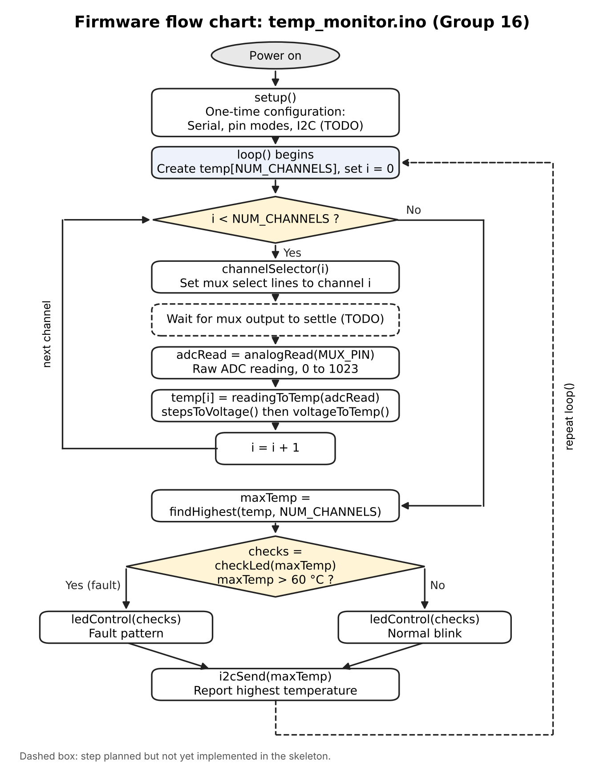
Figure 2: Firmware flow chart

4.1 Program structure
setup() runs once to configure the serial port, the output pins (mux select lines, mux enable and LED) and I2C. loop() then repeats indefinitely:
- For each channel i from 0 to NUM_CHANNELS − 1: select channel i on the mux, read the analog pin with analogRead(), convert the reading to a temperature, and store it in slot i of the temperature array (1D array).
- Find the highest temperature in the array.
- Determine whether it exceeds 60 °C.
- Update the LED (normal blink, or fault pattern).
- Send the highest temperature over I2C.
Functions:
- channelSelector(channel): sets the MUX select lines to the binary value of the channel. Returns nothing.
- readingToTemp(reading): converts an ADC reading to °C by calling stepsToVoltage, then voltageToTemp.
- findHighest(temperatures, count): returns the highest temperature in the array.
- checkLed(temperature): returns true if the temperature in the argument is above 60 °C.
- ledControl(fault): controls the LED. Returns nothing.
- i2cSend(temperature): sends the highest temperature over I2C. Returns nothing.
- analogRead(pin): built-in Arduino function [3]. Reads the voltage on the given analog pin (the mux output, MUX_PIN) with the 10-bit ADC and returns a value from 0 to 1023.
Helper functions:
- stepsToVoltage(reading): converts an ADC reading to the sensor voltage: V = reading × V_ref ÷ 1024 ÷ 2, where 2 is the conditioning gain.
- voltageToTemp(voltage): converts volts to °C using the datasheet table.

4.2 Design decisions
- One value per conversion function. Each conversion helper takes one value and returns one value, so each can be tested against hand calculations: for example, a reading of 800 should give 1.9531 V and 17.63 °C. loop() stores each result in the array.
- Sensor table as a constant. The 33 datasheet voltages (−40 °C to 120 °C in 5 °C steps) are stored once as a const array. Temperatures are evenly spaced, so a table index converts directly to a temperature and only voltages need storing [1].
- Channel count as a single constant [4], [5]. NUM_CHANNELS sizes the array and bounds the loop. It is 16 for the CD74HC4067 schematic and 8 for the CD4051BE build, so switching requires one edit. The CD4051BE also uses 3 select lines instead of 4, so the select-line pin constants change with it.
- Temperature array passed with its count. findHighest receives the array and the count as arguments rather than reading a global, so it works for any channel count and can be tested with made-up arrays.
- The sensor is non-linear, and the datasheet recommends linear interpolation between table values for reasonable accuracy, so we used it [1].
- We considered a 2D array of temperature–voltage pairs, but because the temperatures are evenly spaced (T = −40 + 5k), they are computed from the table index, so only the voltages need storing.
- ADC conversion uses 1024 [2], matching the ATmega328P datasheet's conversion formula. The difference from 1023 is about 0.1%.
- MUX settling. The multiplexer settles in about 80 ns (Section 3.3), well within the ADC's sampling time, so no extra delay is added before each reading.

4.3 Math explanation
Step 1: ADC reading to sensor voltage. The Nano's ADC is 10-bit, so a reading is numbered from 0 to 1023, with a 5 V reference [2]. One count (LSB) is 5 ÷ 1024 = 4.88 mV. The conditioning stage multiplies the sensor voltage by 2, so:
V_ADC = reading × 5 ÷ 1024
V_sensor = V_ADC ÷ 2
Step 2: Voltage to temperature (linear interpolation). The sensor table lists voltages from −40 °C to 120 °C in 5 °C steps. Table index k corresponds to:
T(k) = −40 + 5k
The firmware finds the two entries the voltage falls between, V(k) ≥ V > V(k+1), and interpolates linearly:
fraction = (V(k) − V) ÷ (V(k) − V(k+1))
T = T(k) + 5 × fraction
Because the sensor's voltage falls as temperature rises, V(k) is the higher voltage and T(k) the lower temperature.
Worked example: reading 800
- V_ADC = 800 × 5 ÷ 1024 = 3.9063 V
- V_sensor = 3.9063 ÷ 2 = 1.9531 V
- Bracket: 15 °C (1.99 V) and 20 °C (1.92 V)
- fraction = (1.99 − 1.9531) ÷ (1.99 − 1.92) = 0.0369 ÷ 0.07 = 0.527
- T = 15 + 5 × 0.527 = 17.63 °C (no fault)

4.4 Still to do for the build phase
- Implement and test against calculations.
- Handle readings outside the table range (sensor voltage below 1.30 V or above 2.44 V). These indicate a disconnected or shorted sensor, and interpolation has no bracket outside the table, so they must be detected and reported.

5. Testing and limitations
Testing results will be added after the build phase.

6. References
AI tools were used for planning, research, learning, drafting, and support; all code was written by the authors.
- enepaq, Li-ion building block with Sony/Murata VTC5A, datasheet, rev. E, Jan. 2025. Table 5: sensor voltage vs. temperature.
- Microchip Technology, ATmega328P, datasheet. Analog-to-Digital Converter chapter: conversion result formula.
- Arduino, Language Reference: analogRead(), digitalWrite(), pinMode(), bitRead(), millis().
- Texas Instruments, CD74HC4067, CD74HCT4067 16-Channel Analog Multiplexer/Demultiplexer, datasheet SCHS209D, Dec. 2024.
- Texas Instruments, CD4051B, CD4052B, CD4053B CMOS Analog Multiplexers/Demultiplexers, datasheet SCHS047L, Sep. 2023.

